

Lefel: Mae’r dasg hon yn addas ar gyfer lefel Mynediad

Cymraeg yn y Gweithle
Ymholiadau mewn siop / archfarchnad
gan Caryl Clement

1. Cyflwynwch y canlynol i’r dosbarth, a’u drilio:

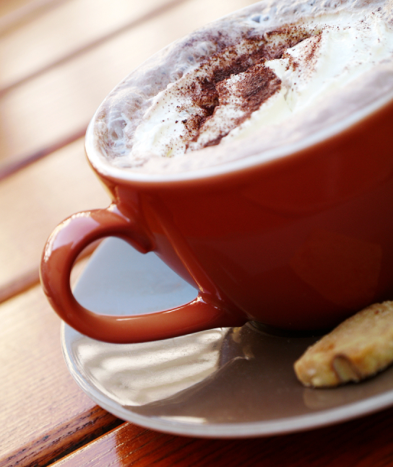
Esgusodwch fi Excuse me

Allwch chi fy helpu? Can you help?

Ble mae’r caffi? Where’s the cafe?

Ble mae’r toiledau? Where are the toilets?

Ble mae’r wyau? Where are the eggs?
cacennau? cakes?
llysiau? vegetables?
ffrwythau? fruit?
sudd oren? orange juice?
bara? bread?
cig? meat?
gwin? wine?
cwrw? beer?
dŵr? water?
coffi? coffee?
te? tea?
pysgod? fish?
siwgr? sugar?
caws? cheese?
llaeth? milk?

2. Rhoi cyfarwyddiadau:

Ar y dde  Ar y chwith  Eil un  Eil dau  Eil tri  Eil pedwar  Eil pump  Eil chwech  Eil saith  Eil wyth  Eil naw  Eil deg  Eil un deg un  Eil dau ddeg pump  Dewch gyda fi  Dyma nhw  Dyma fe  Nesa at y caws  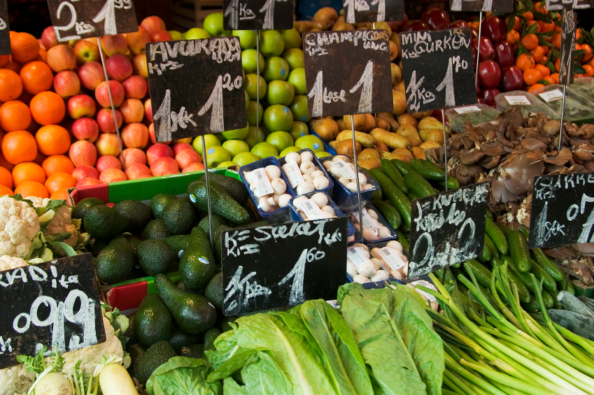  Ar bwys y ffrwythau | On the right  On the left  Aisle one  Aisle two  Aisle three  Aisle four  Aisle five  Aisle six  Aisle seven  Aisle eight  Aisle nine  Aisle ten  Aisle eleven  Aisle twenty five  Come with me  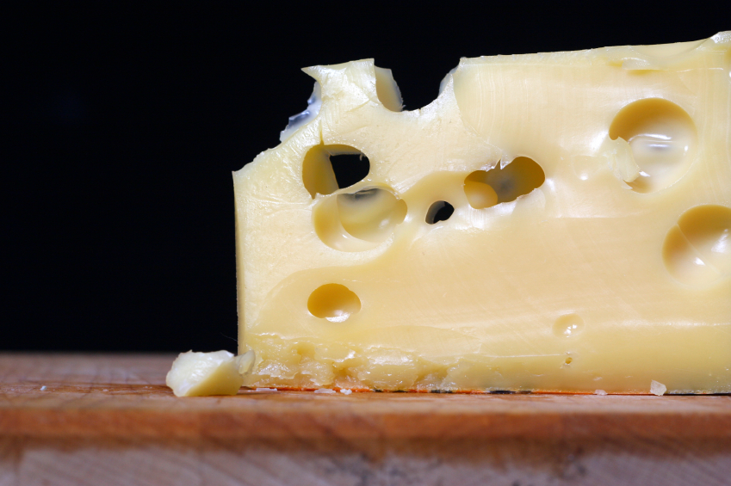  Here they are  Here it is  Next to the cheese  Near to the fruit

3. Deialog:
Ar ôl cyflwyno’r sgwrs, rhannwch y dosbarth yn barau i greu eu sgyrsiau eu hunain. Bydd rhaid iddynt ddefnyddio Cynllun yr Archfarchnad (isod) a disodli’r geiriau sydd mewn print trwm.

A: Esgusodwch fi, dych chi’n siarad Cymraeg?
B: Tipyn bach.
A: Ble mae’r ffrwythau?
B: Eil dau, ar y dde, nesa at y pysgod.
A: Diolch

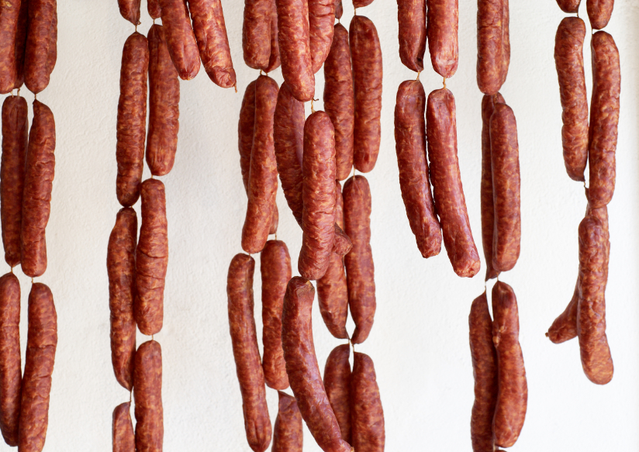

Cynllun yr Archfarchnad

Eil 1 Eil 2 Eil 3

Ffrwythau |  | Llaeth | Bara |  | Caws | Llysiau |  | Te
Bara |  | Te | Sudd  Oren |  | Gwin | Coffi |  | Cig
Gwin |  | Dŵr | Cig |  | Dŵr | Caws |  | Llaeth
Pysgod |  | Siwgr | Gwin |  | Llysiau | Pysgod |  | Cwrw
Cacennau |  | Coffi | Cacennau |  | Ffrwythau | Sudd  Oren |  | Gwin
Caws |  | Llysiau | Te |  | Pysgod | Bara |  | Siwgr
Sudd  Oren |  | Cig | Cwrw |  | Siwgr | Ffrwythau |  | Dŵr
Cwrw |  | Gwin | Llaeth |  | Coffi | Cacennau |  | Gwin

DRWS

4. Gwaith Cartref

Cyfieithwch:

I don’t understand
Slowly, please
Next to the meat
Near the wine
Excuse me

A little
Here they are
Come with me
Aisle ten
Where are the toilets

